Exercise 3: Assertions in JUnit
This document covers the steps I followed to complete Exercise 3, where the goal was to practice using different types of JUnit assertions to validate test results.

What I Did
Since JUnit was already set up in the project from the earlier exercises, I didn't need to configure anything new. I simply added a new test class called AssertionsTest inside the existing org.example package, under src/test/java, right next to MainTest.java.
In this class, I wrote a single test method named testAssertions() that demonstrates five different JUnit assertion methods:
- assertEquals() – checks that 2 + 3 equals 5
- assertTrue() – checks that the condition 5 > 3 is true
- assertFalse() – checks that the condition 5 < 3 is false
- assertNull() – checks that a null value is indeed null
- assertNotNull() – checks that a new Object() is not null

Test Code
The final AssertionsTest.java file looks like this:
package org.example;

import org.junit.Test;
import static org.junit.Assert.*;

public class AssertionsTest {

@Test
public void testAssertions() {
// Assert equals
assertEquals(5, 2 + 3);

// Assert true
assertTrue(5 > 3);

// Assert false
assertFalse(5 < 3);

// Assert null
assertNull(null);

// Assert not null
assertNotNull(new Object());
}
}

Running the Test
Below is a screenshot of the AssertionsTest.java file open in IntelliJ IDEA, before running the test.
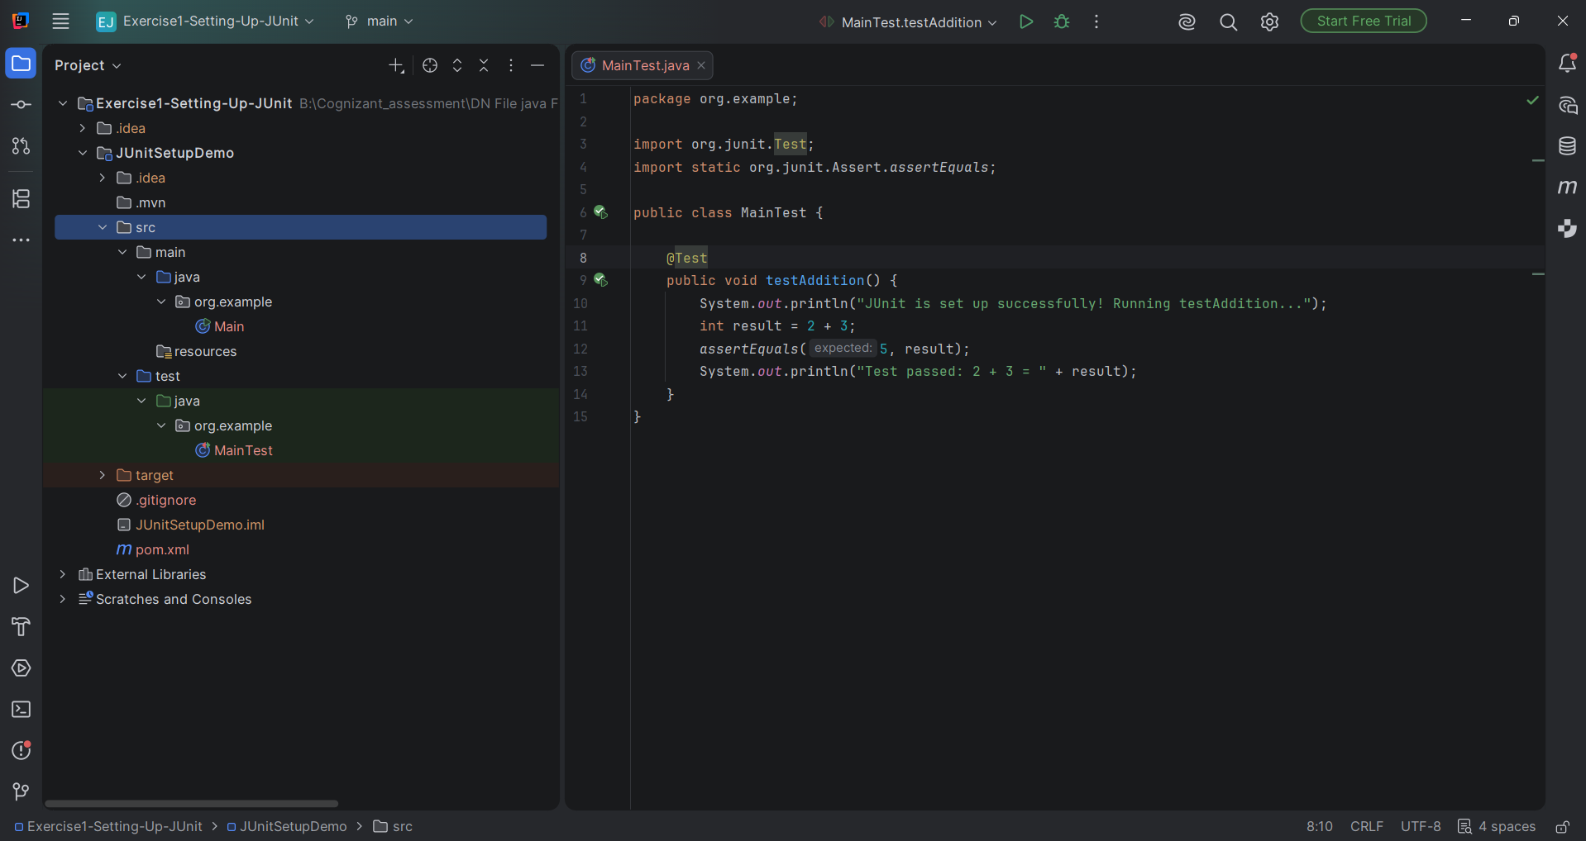
After running the test, IntelliJ's Run panel confirmed that the test executed successfully:
- AssertionsTest.testAssertions() shows a green checkmark
- The summary reads "1 test passed"
- The console output shows "Process finished with exit code 0"
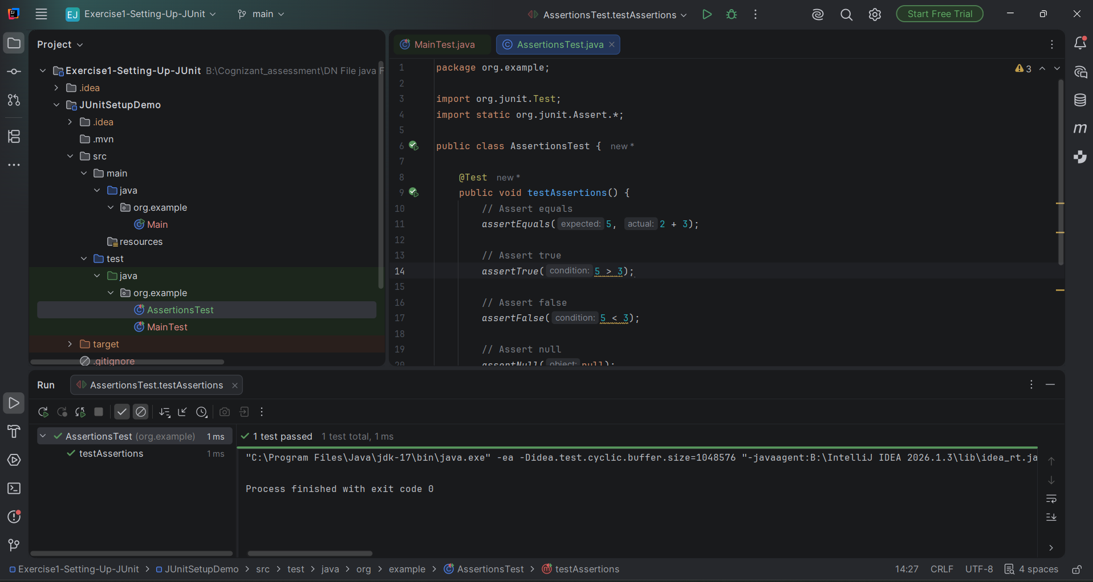

Result
All five assertions passed without any errors, confirming that assertEquals, assertTrue, assertFalse, assertNull, and assertNotNull all behave as expected. This completes Exercise 3 successfully.

